MICROCONTROLLER-BASED INFANT CRY DETECTION AND ALERT SYSTEM FOR NEONATAL INTENSIVE CARE UNITS.


DATE: 16TH MARCH, 2026.
PRESENTED BY: MICROPROCESSORS GROUP 3, BIOMEDICAL ENGINEERING.

PROBLEM STATEMENT
Neonates require near constant supervision and support within a Neonatal Intensive Care Unit (NICU) setting due their inability to verbally express their status (e.g. pain, hunger, discomfort) using spoken language. The main method for neonates to express discomfort or need is by crying. Unfortunately, the NICU nurse is typically responsible for caring for many infants at one time and the noise generated by medical equipment and devices within the NICU may prevent the nurse from immediately recognizing that an infant is crying. If the nurse does not identify that an infant is crying in a timely manner, this could result in negative outcomes for the infant or could potentially delay the infant returning to optimum health. Thus, the identification of an automatic monitoring system for detecting infant crying and generating an alert for NICU nurses becomes of utmost importance.
The project "Microcontroller Based Cry Detection and Alarm System for Neonatal Intensive Care Units" is intended to address this gap. The project will utilize a microcontroller and sound detection sensor to detect infant crying, allowing the NICU nurse to receive immediate notice of an infant needing assistance through an alerting mechanism.

PROJECT OBJECTIVES
GENERAL OBJECTIVE.
- To design, simulate and implement an effective and functional prototype of a microcontroller-based system that detects infant crying and automatically alerts healthcare staff in the Neonatal Intensive Care Unit.
SPECIFIC OBJECTIVES.
- To develop a sound detection circuit system capable of capturing infant cry signals.
- To program a microcontroller to analyze the sound signal and identify crying patterns.
- To design an alert mechanism (using a buzzer) that notifies nurses when crying is detected.
- To produce a functional hardware prototype of the simulated system.
- To test and evaluate the performance of the system in detecting infant cries accurately.
- To create a low-cost and reliable monitoring system suitable for healthcare environments.

METHODOLOGY
- System Overview.
The proposed system is a microcontroller-based infant cry detection and alert system designed for use in Neonatal Intensive Care Units (NICUs). The system continuously monitors audio signals from the infant’s environment, processes them, and triggers an alert when a cry is detected.
- System Design Approach.
The design follows a modular approach consisting of:
- Input Stage (Sound Acquisition)
- Signal Processing Stage
- Decision-Making Stage
- Output/Alert Stage
3. Hardware Components.
a. Sound Sensor.
A high-sensitivity microphone is used to capture sound signals from the infant’s surroundings. The sensor converts acoustic signals into electrical signals.
b. Microcontroller Unit.
A microcontroller (Arduino) is used to:
- Read input signals from the microphone
- Process and analyze sound patterns
- Execute decision-making algorithms
c. Signal Conditioning Circuit.
This stage may include:
- Amplifiers to boost weak signals
- Filters to remove background noise
d. Output Devices.
- Buzzer (for immediate alerts)
- LED indicators
4. Software and Algorithm Design.
a. Signal Acquisition.
The microphone continuously captures sound and sends analog signals to the microcontroller.
b. Signal Processing.
The system processes the signal using:
- Amplitude thresholding
- Frequency analysis (to differentiate crying from noise)
c. Cry Detection Logic.
The system identifies infant crying based on:
- Sound intensity (above a preset threshold)
- Characteristic frequency patterns of infant cries
- Duration of the sound signal
d. Decision Algorithm.
If the detected sound meets the criteria for a cry:
- The system confirms it as a valid event
- False positives (e.g., noise, speech) are filtered out
5. Alert Mechanism.
Once a cry is detected:
- A buzzer is activated for immediate response
- A visual indicator (LED/display) is triggered
6. Testing and Validation.
The system is tested under different conditions:
- Quiet environment
- Background noise (equipment, conversations)
- Multiple sound sources
Performance metrics include:
- Detection accuracy
- Response time
- False alarm rate
7. Implementation Environment.
The system is designed to be:
- Low-cost
- Energy-efficient
- Easy to deploy in hospital environments

SIGNIFICANCE OF THE PROJECT
- This problem solves a real clinical problem: Infant monitoring is crucial in neonatal care as most of the neonates are premature and demand constant attention. This microcontroller system provides a practical technological solution to improve patient care.
- Combines engineering and healthcare: this project integrates; Embedded systems, biomedical engineering and signal processing to provide a technological solution for improved healthcare.
- Opportunity for future development and innovations: This microcontroller-based project can be expanded to include:
- Wireless alerts to nurses’ stations
- Smartphone or pager notifications.
- Integration with other infant monitoring system
- Strong academic value: This project demonstrates skills in;
- Microcontroller programming.
- Embedded system design.
- Sensor interfacing.
- Signal detection.

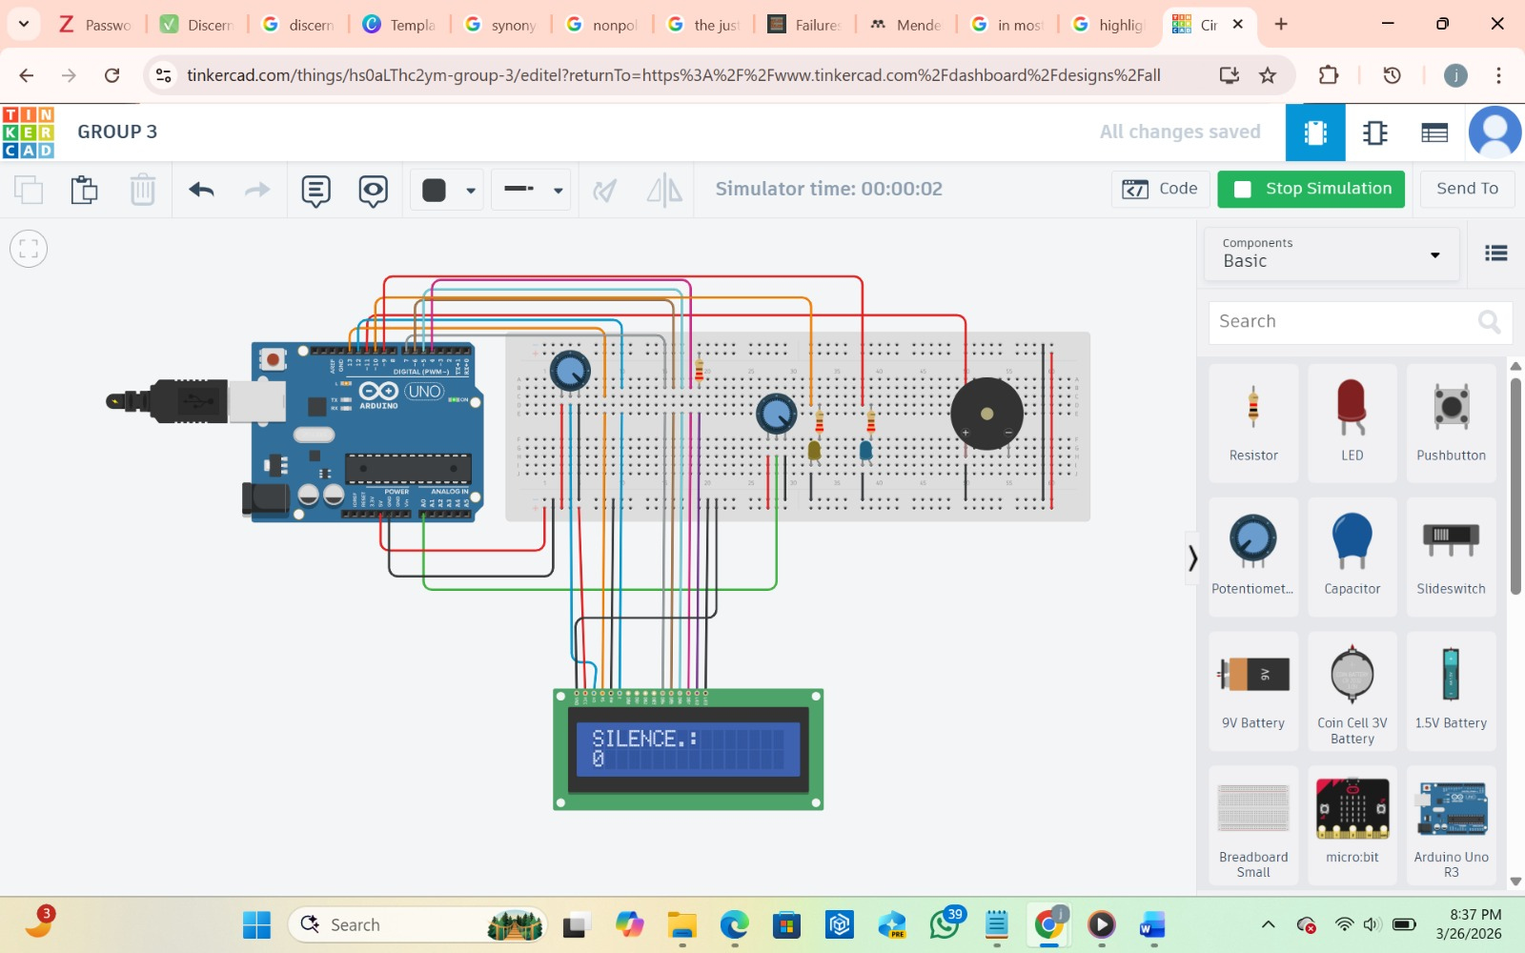
PROJECT SIMULATION
Figure 1: Arduino circuit display when no noise is detected in the background

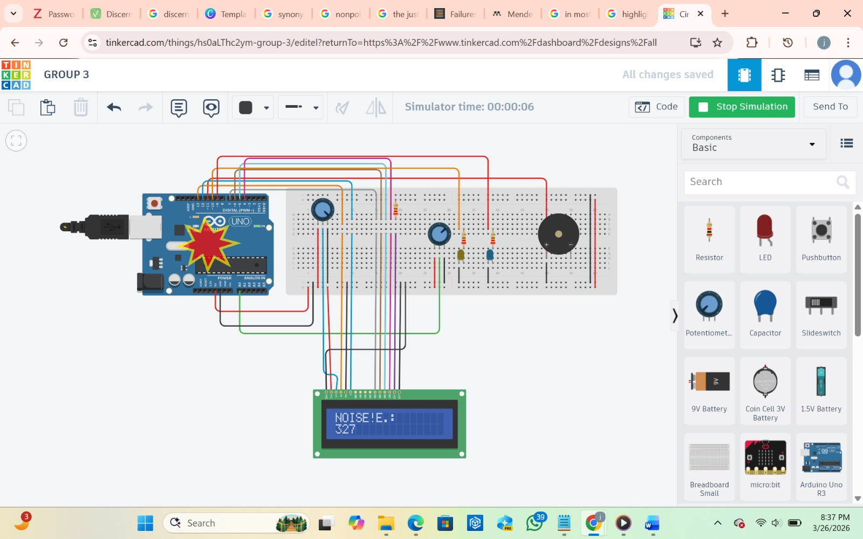
Figure 2: Arduino circuit display when noise is detected in the background

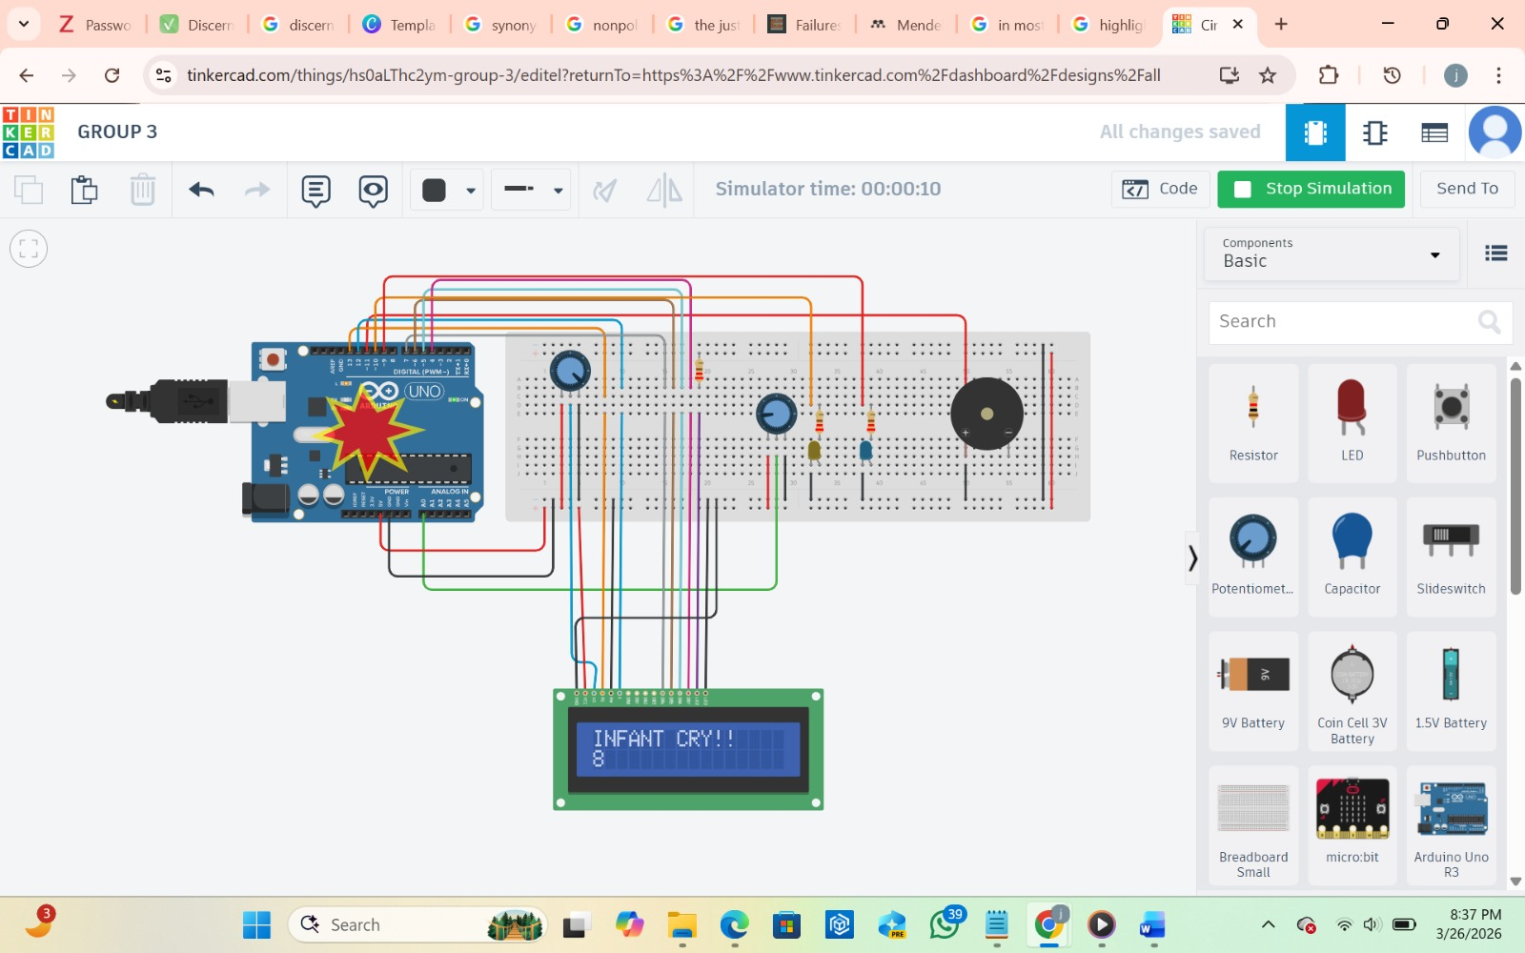
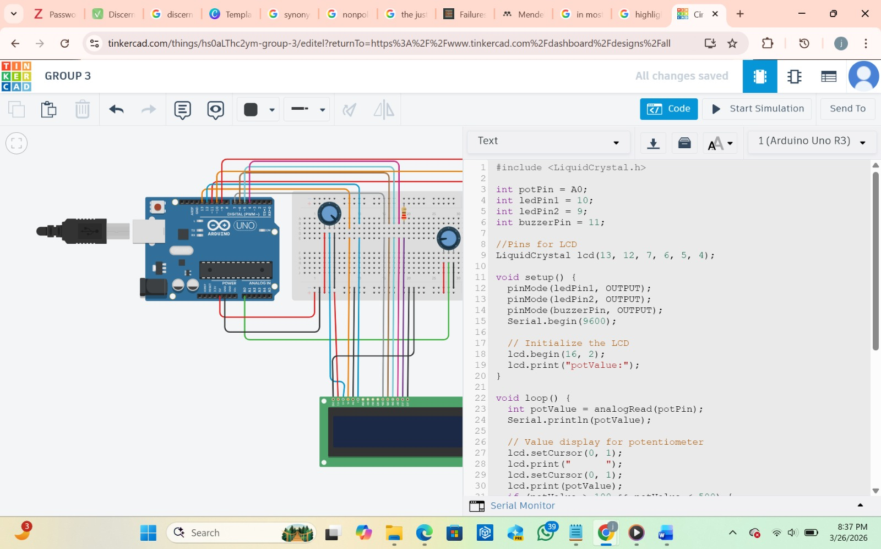
Figure 4: Arduino circuit display when the noise is processed and interpreted as infant cry when it crosses a pre-set threshold frequency.
Figure 3: Code for our Arduino circuit simulation in tinker cad.
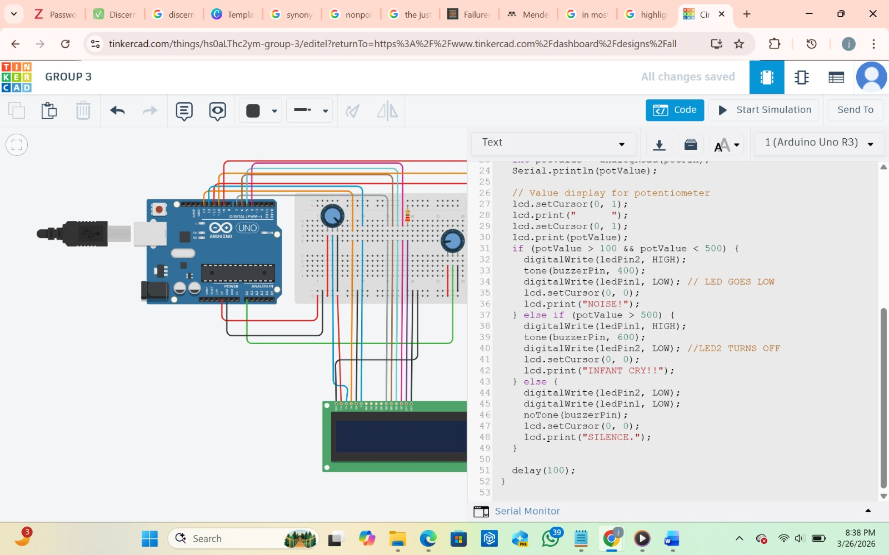
Figure 5: Ending block of code for our Arduino circuit simulation
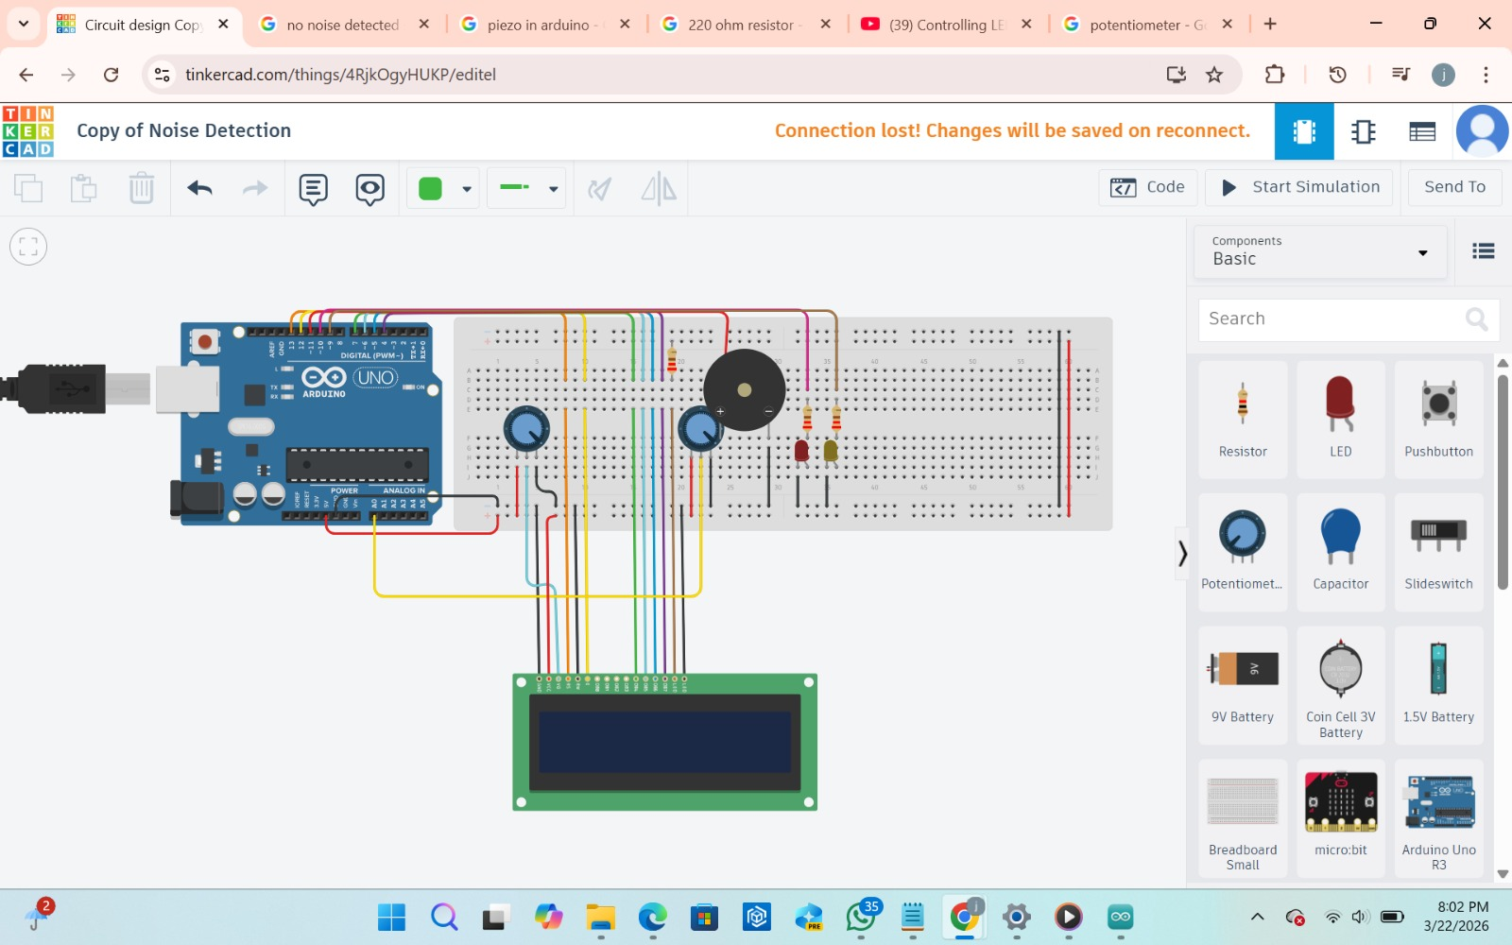
Figure 6: Arduino circuit in tinker cad with LCD display and other components
KEY TAKEAWAYS
- The system provides an automated and reliable method for detecting infant cries in NICUs.
- It helps reduce the workload on nurses by ensuring no critical cry goes unnoticed.
- The use of a microcontroller makes the system cost-effective and scalable.
- Signal processing techniques improve accuracy by minimizing false alarms.
- Real-time alerts enable faster response and improved infant care.
- The system can be extended with IoT features for remote monitoring.
- It demonstrates the practical application of embedded systems in healthcare.
- Overall, the project contributes to enhancing patient safety and caregiving efficiency.

POSSIBLE FUTURE ENHANCEMENTS AND INNOVATIONS
The proposed microcontroller-based infant cry detection system provides a solid foundation for automated monitoring in NICUs. However, several enhancements can be implemented to improve its accuracy, functionality, and overall impact in clinical settings.

1. Integration of Machine Learning Algorithms
Future versions of the system can incorporate machine learning techniques to improve cry detection accuracy. Instead of relying only on amplitude and frequency thresholds, models can be trained to:
- Differentiate between types of cries (hunger, pain, discomfort)
- Adapt to different infants and environments
- Reduce false positives caused by background noise
This would significantly enhance the system’s intelligence and reliability.
2. IoT-Based Remote Monitoring
The system can be upgraded with Internet of Things (IoT) capabilities to enable:
- Real-time notifications to nurses’ smartphones or monitoring stations
- Centralized monitoring of multiple infants simultaneously
- Data logging for medical review
This would allow caregivers to respond more quickly, even when they are not physically close to the infant.
3. Mobile Application Development
A dedicated mobile application can be developed to:
- Receive instant alerts
- Display real-time audio activity
- Provide system status updates
This enhances usability and improves communication between the system and healthcare providers.
4. Multi-Sensor Integration
To improve accuracy and context awareness, additional sensors can be incorporated, such as:
- Temperature sensors
- Heart rate monitors
- Motion sensors
Combining multiple physiological parameters with cry detection would provide a more comprehensive assessment of the infant’s condition.
5. Advanced Noise Cancellation Techniques
Future systems can implement more sophisticated noise filtering methods, such as:
- Adaptive filtering
- Digital signal processing (DSP) techniques
This would allow the system to function more effectively in noisy NICU environments with medical equipment and human activity.
6. Wireless Communication Enhancements
Instead of basic alert systems, the device can include:
- Wi-Fi or Bluetooth modules
- Integration with hospital monitoring systems
This ensures seamless communication within modern healthcare infrastructure.

7. Miniaturization and Wearable Design
The system can be redesigned into a compact or wearable form, such as:
A clip-on device for incubators
A soft wearable patch
This would improve portability, comfort, and ease of use in clinical settings.
8. Data Collection and Predictive Analytics
Collected data over time can be used to:

- Identify patterns in infant crying behavior
- Predict potential health issues early
- Support clinical decision-making
This transforms the system from a reactive tool into a predictive healthcare solution.

9. Energy Efficiency and Battery Optimization
Future designs can focus on:
- Low-power microcontrollers
- Efficient battery management systems
- Rechargeable or long-life power sources
This ensures continuous operation without frequent maintenance.

GROUP 3 MEMBERS
1. Hayford Dela Ahiamadzor -7292723
2. Victor Kofi GBEDASI- 7295323
3. Adjei-Sah Jasmine Asantewaa -7291523
4. ⁠Dokurugu Rejoice Wunnam- 7295023
5. ⁠ Ibrahim Abdul Razak - 7295523
6. ⁠Agyemang Eunice- 7292523
7. Darko-Ameyaw Faith - 7294623
8. Solomon Azameti -7293523
9. Doe Racheal Arku Yorm-7294923

